CSCE 606 Iteration 4

Team: Flyer

# Customer meeting date to demo this iteration:

We met our customer Dr. Yu on 12/02/2016 Friday afternoon.

# Main work this week

1. We discussed our work with customer. The followings are several suggestions from customer:

- Search

- to make the search box bigger

- one needs to be able to select how many datasets to display per page.

- User make selections on the questoins (bug fix: clear bottom)

- Seperate the keywords and datasets (*)

- for each keyword -> load all the datasets (optionally, the group admin may select a subset of the datasets to assign to users

- For each keyword associated it with one or more questions

- Multiple keywords may have the same question.

- For question answers, two modes

- multiple choices (select only one, or multiple)

- free form (no statistics)

- multiple choices & free form

- Based on the free form questions,group admin may design new questions on selected datasets.

1. We complete statistics function planned for this iteration.
2. We have debugged and improved interfaces.

# User stories implemented in this iteration:

Feature: Viewing my submission

As a user

So that I can review my answers

I want to view my submission of questions

Feature: Recording the curation results

As a administrator

So that I can choose curators who can be trusted more

I want to evaluate curators based on their past performance

Feature: Statistics of answers

As a administrator

So that I can have an intuitionistic knowledge of the curation results

I want to calculate the accuracy of each questions and draw graphs

# Views

## Views for statistics:

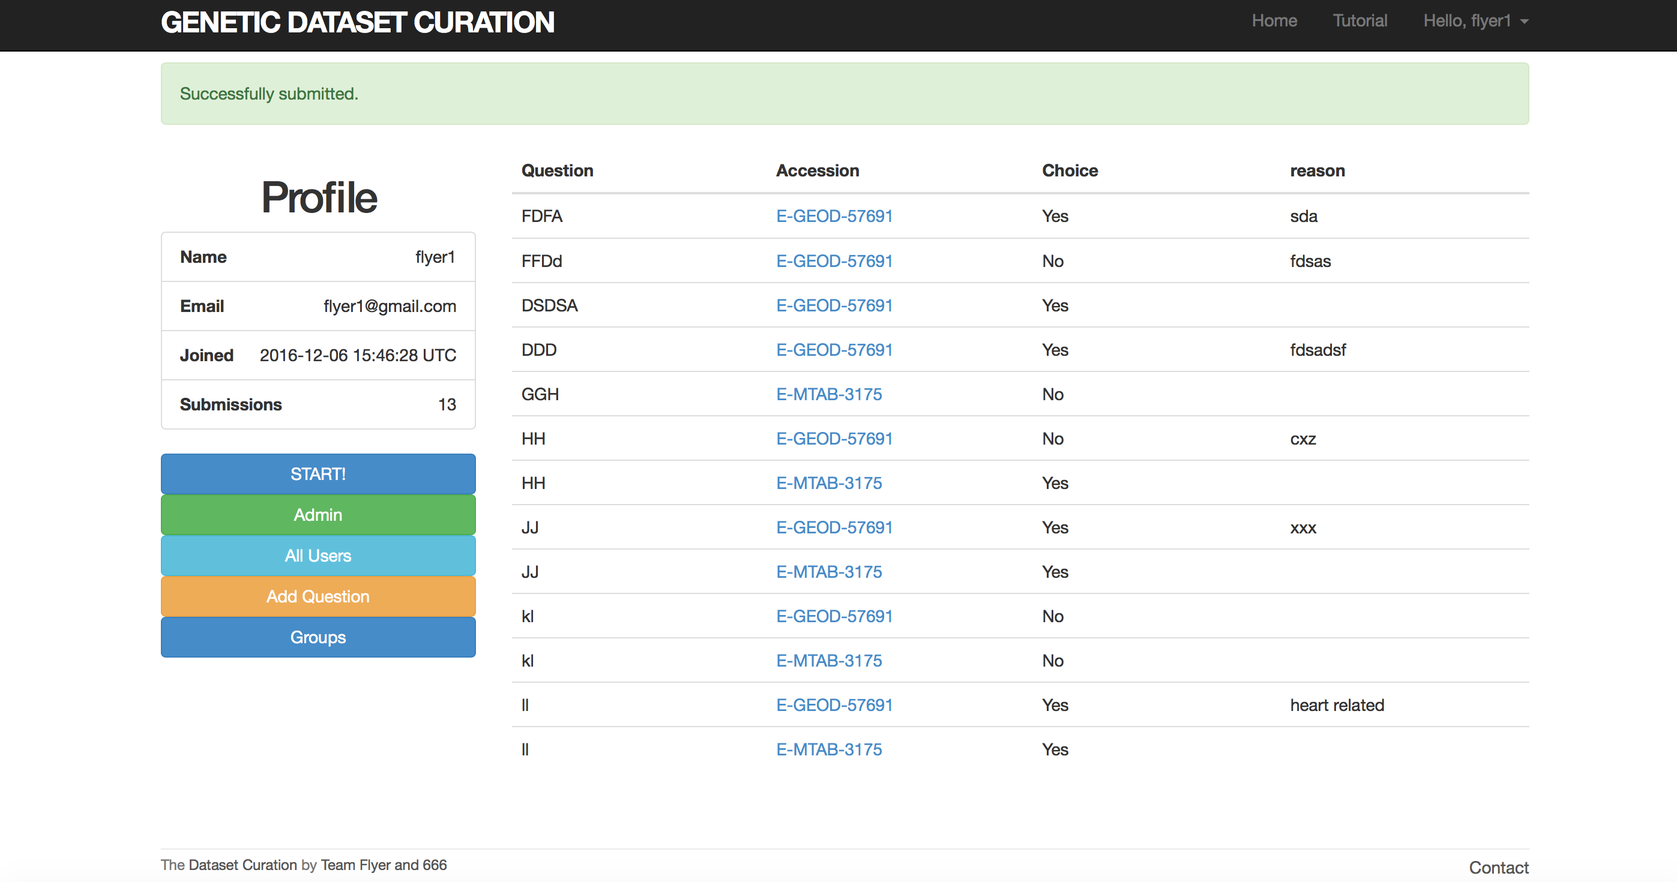

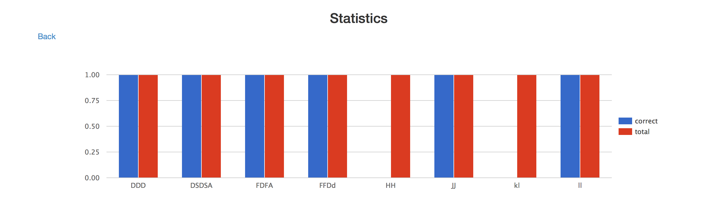

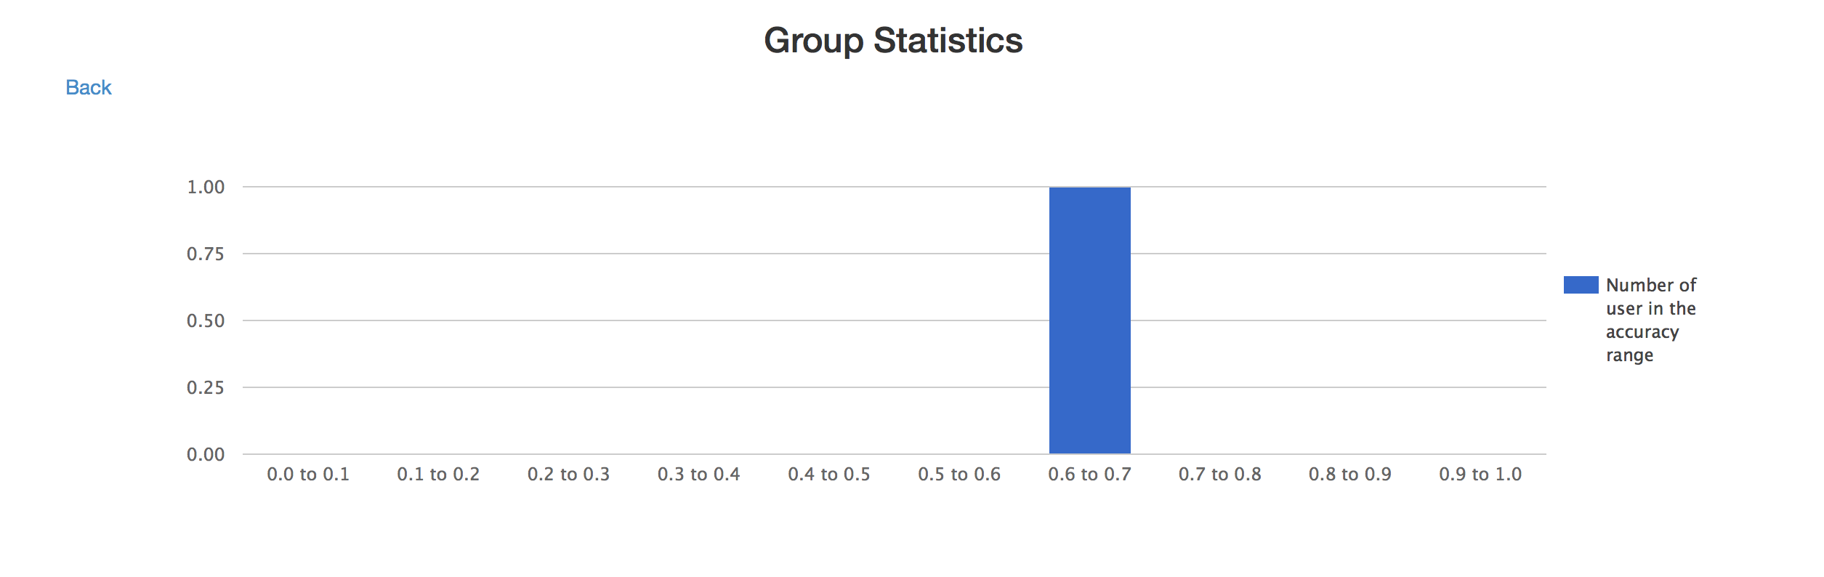

Features changes:

Admin Page Reconstruction:

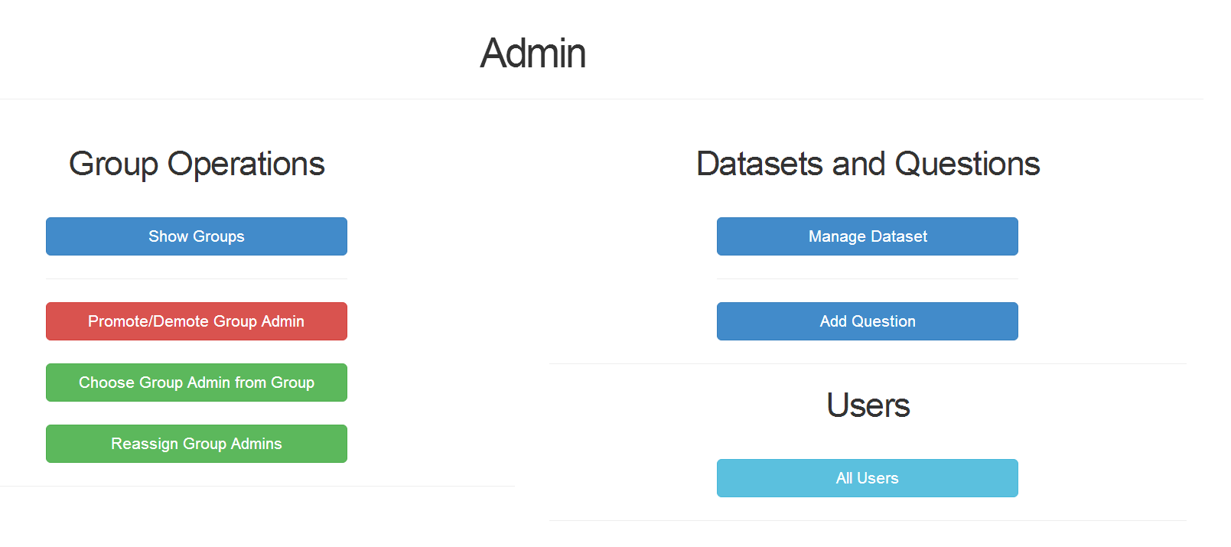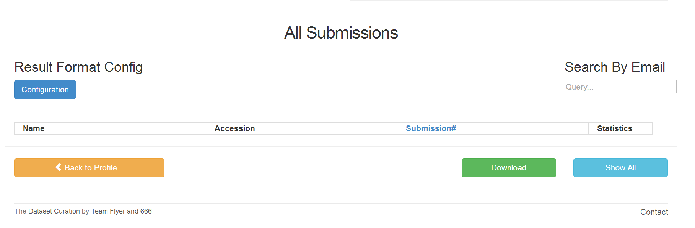

Buttons of the groups update:



Multiple pages support on each group operation:

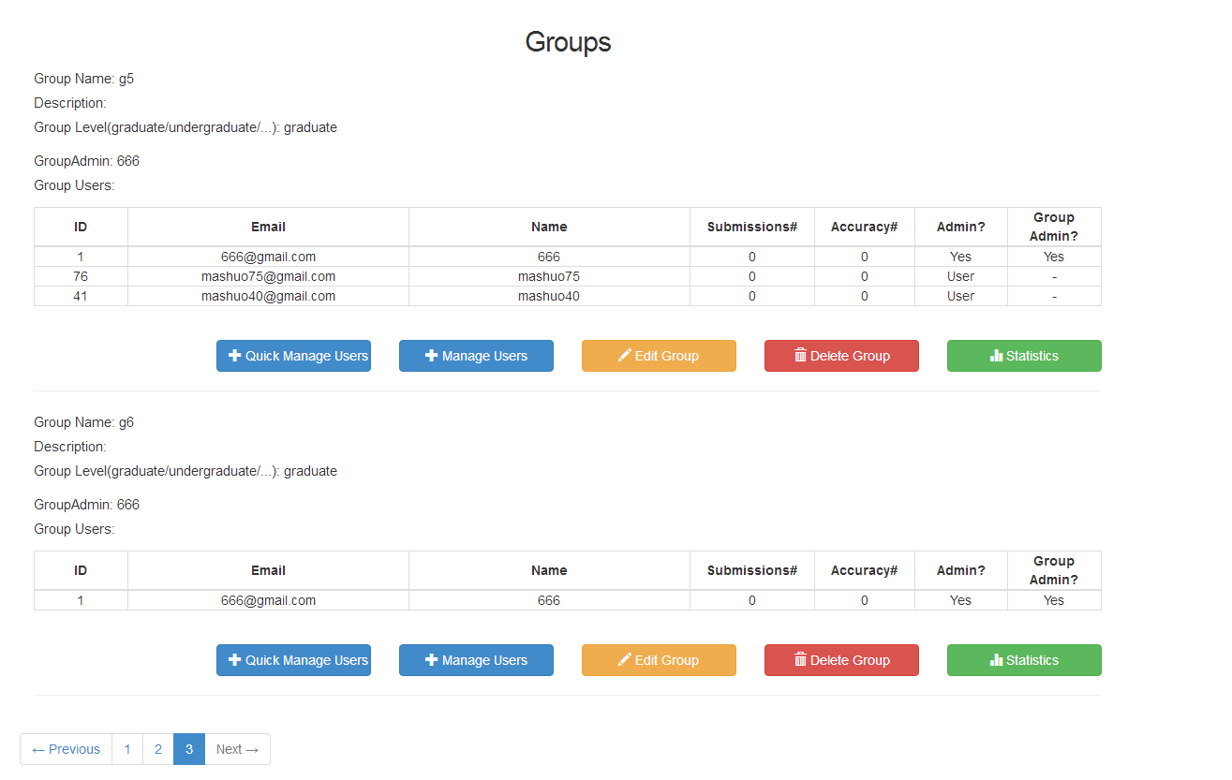

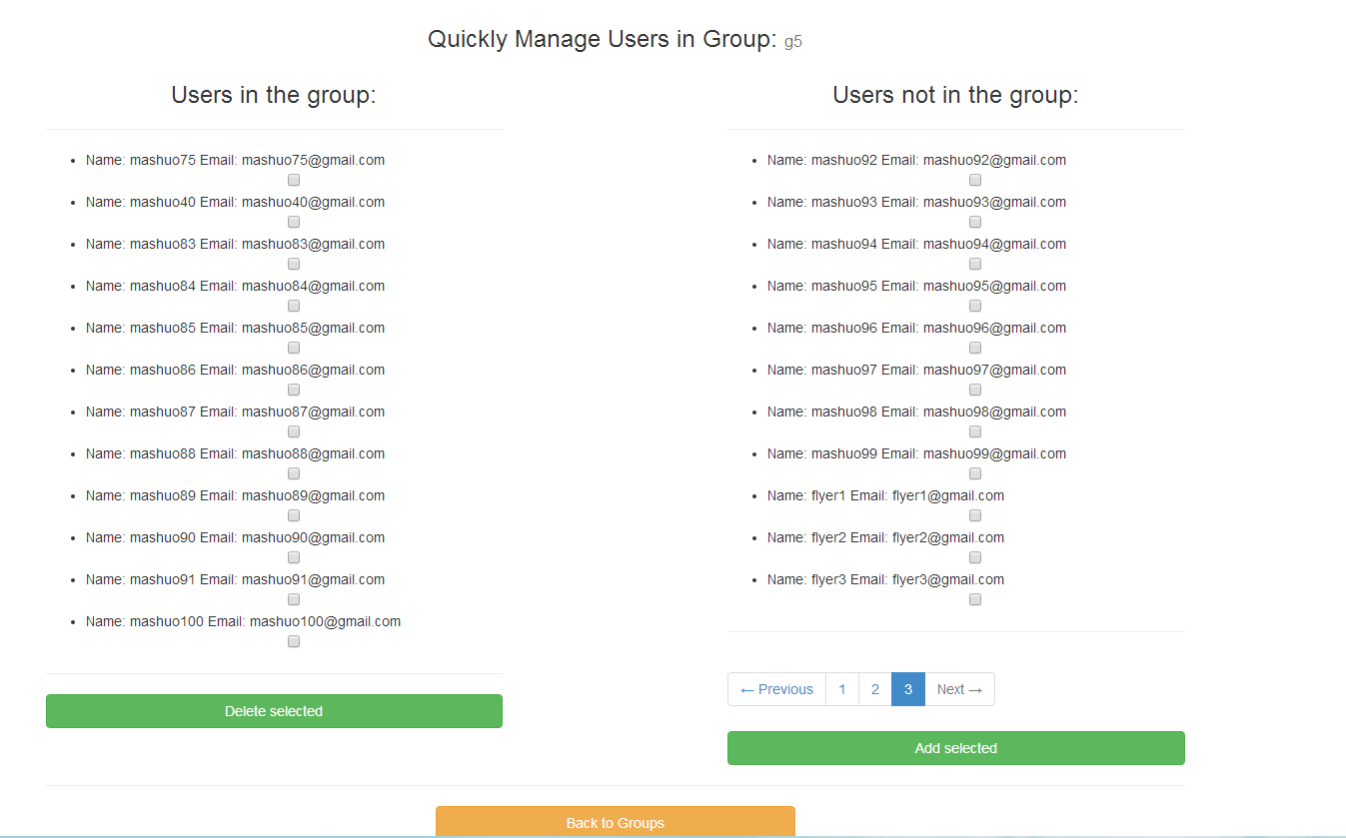

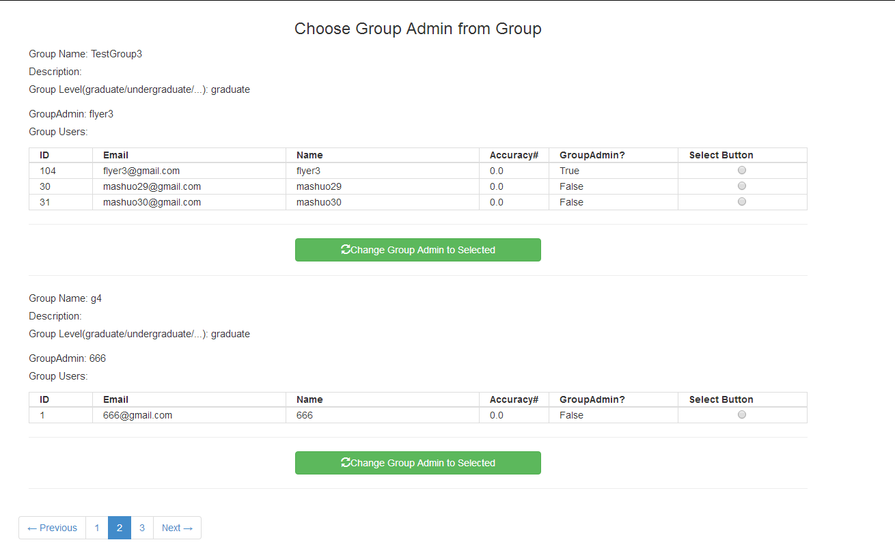

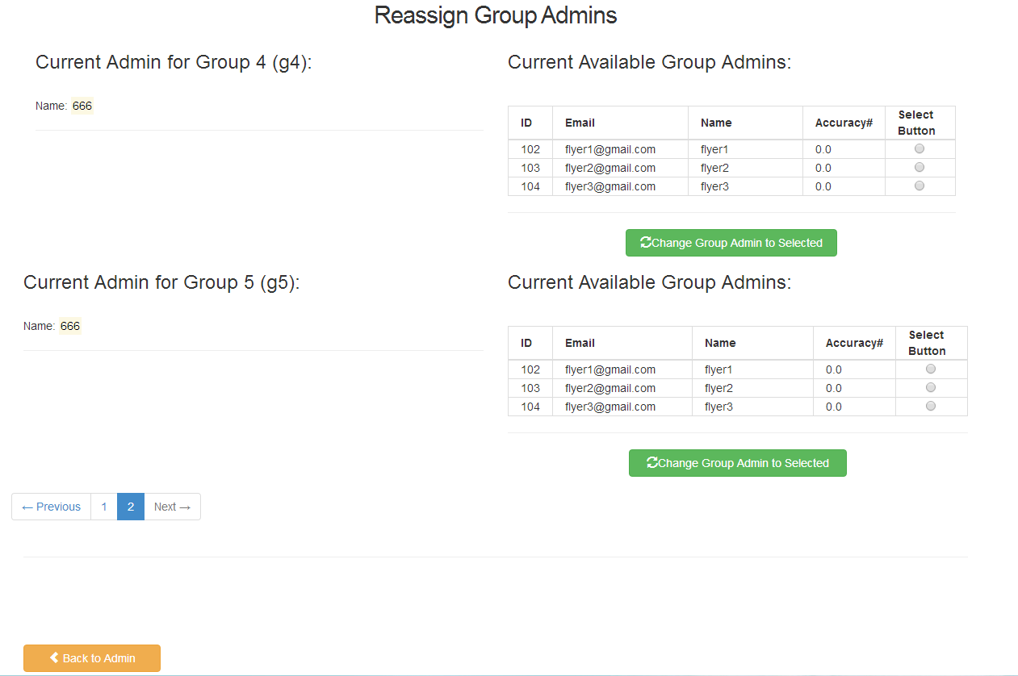

# TDD&BDD for group function:

Fullquestions Model Rspec:

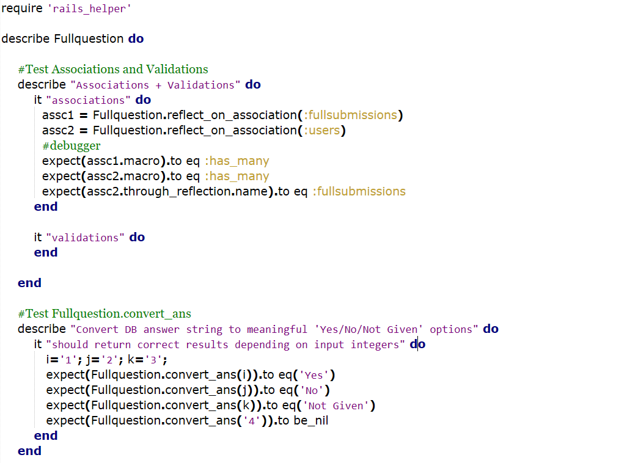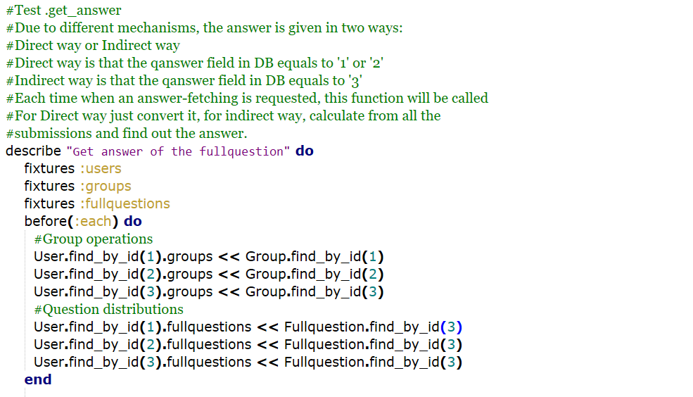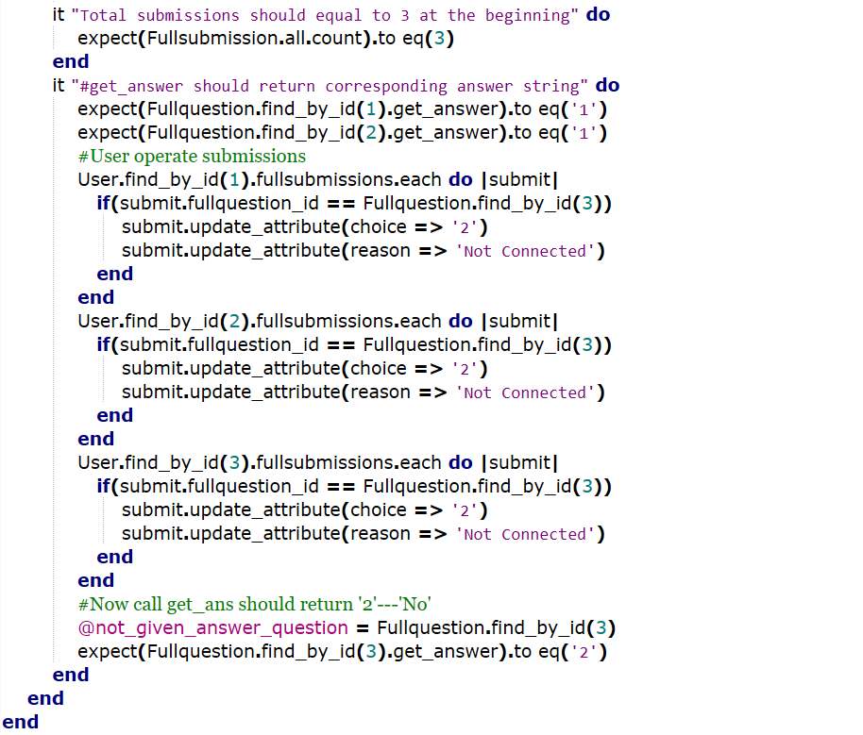

Test Result:

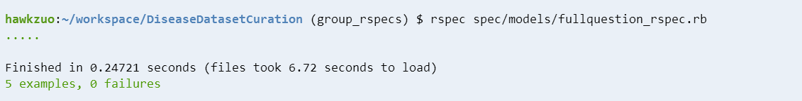

Groups enhanced Rspec (Add Associations and Validations) :

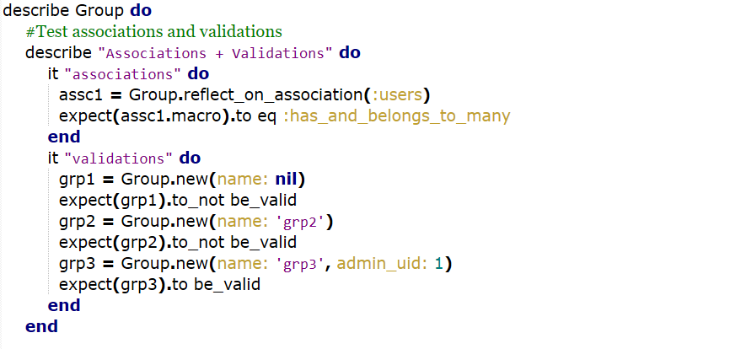

Test Result:

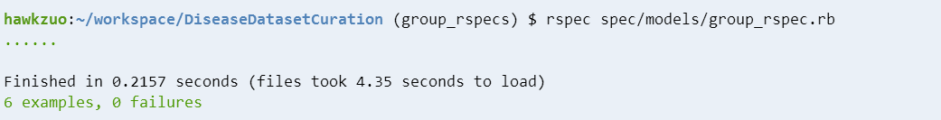

Groups Controller enhanced Rspec (Add #performadd and #quickadduser ):

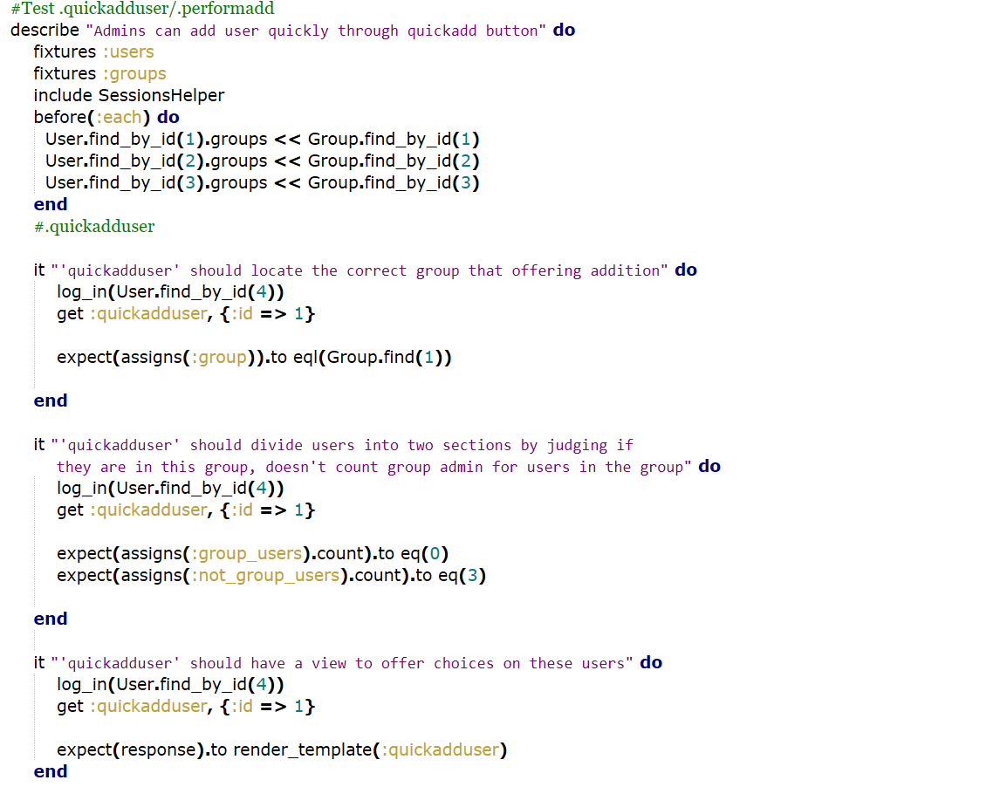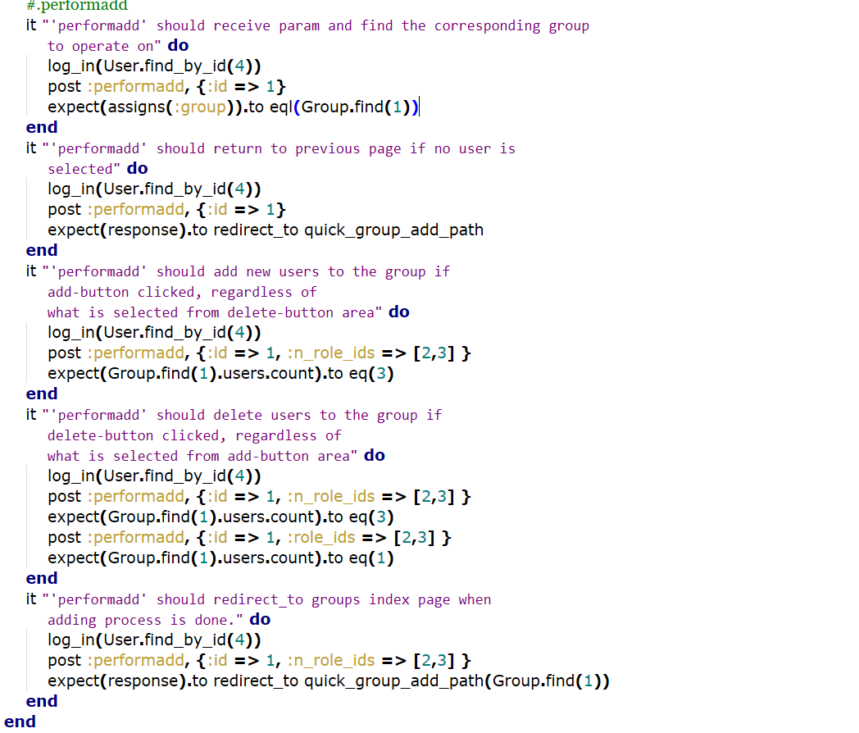

Test Result:

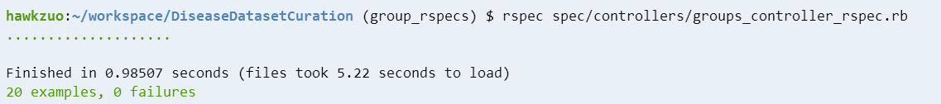

# Pivotal Tracker, Github repo, and Heroku links:

Pivotal: <https://www.pivotaltracker.com/n/projects/1887551>

Github: <https://github.com/xvxiaopei/CSCE606-project>

Heroku: <http://disease.herokuapp.com/>